Monaco Guide
The Dynatrace Monaco CLI is a native tool for Dynatrace Configuration as Code. It enables you to manage your monitoring environment through configuration files, offering a range of features to streamline the process.
DOWNLOAD CONFIGURATIONS:
Install the Dynatrace Monaco CLI
Windows
- Open Windows PowerShell.
- Download the latest version of the Dynatrace Configuration as Code CLI tool(Monaco) by running the following command.
- Invoke-WebRequest -URI https://github.com/Dynatrace/dynatrace-configuration-as-code/releases/latest/download/monaco-windows-amd64.exe -OutFile monaco.exe
- To verify if the installation was successful. You can run the following command and it should return the output as in the screenshot:
- Monaco

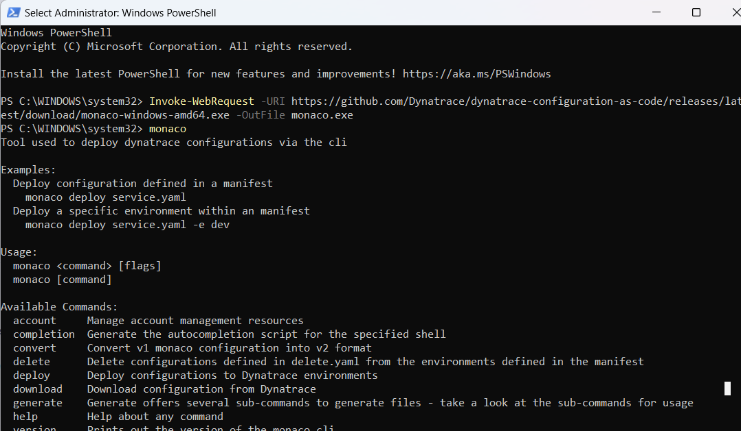

With the Monaco CLI downloaded and set up, we can now move forward with downloading configuration as code from any Dynatrace Environment.
- To download the Configurations as Code, begin by creating a specific directory or folder where all the configuration files will be saved.

- Generate an access token from the environment from which you want to download configurations, ensuring it has the specified scopes.
- Add this token to the system environment variable and give it a name.
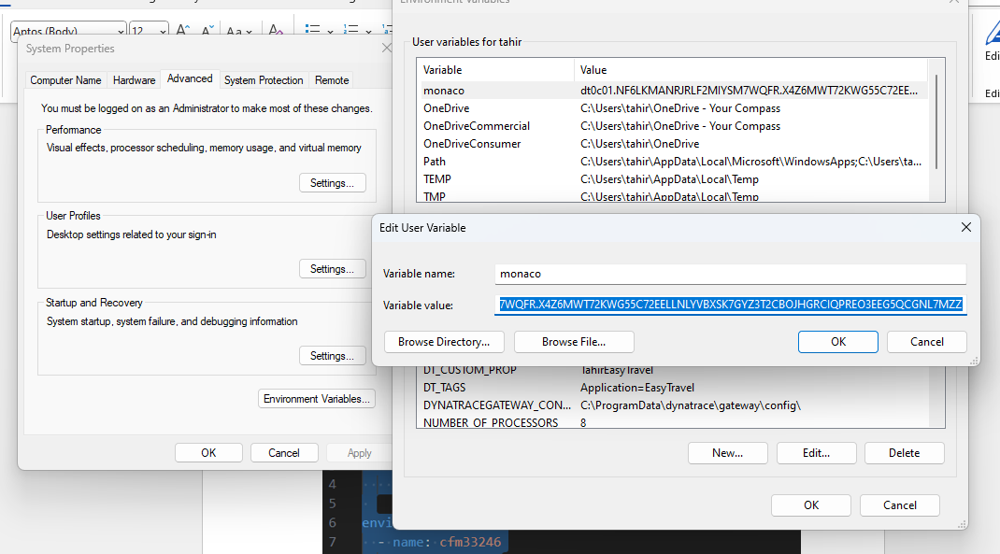

- Create a manifest.yaml file in the same directory and include the following YAML code in the file.

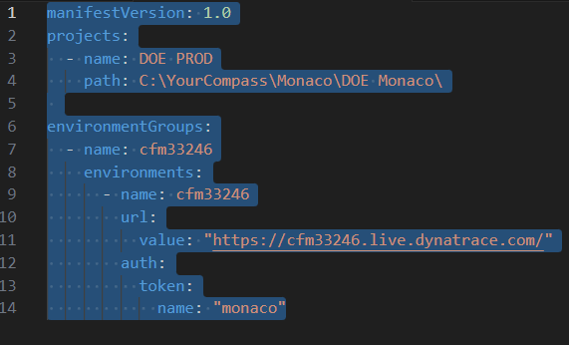

Project Section
Assign an appropriate name to the project and specify the path where you want to download the configurations, using the path created earlier.
EnvironmentGroups Section
For the name, you can use tenantId/environmentId. The URL should be the Dynatrace tenant URL, and the token name should match the name of the access token saved in the system variables. Although you can use the access token directly, it is not considered best practice.

Once the changes are complete, open the command prompt in the same directory or navigate to the path where the manifest.yaml file is saved, and then run the following command.

monaco download --manifest .\manifest.yaml --environment cfm33246

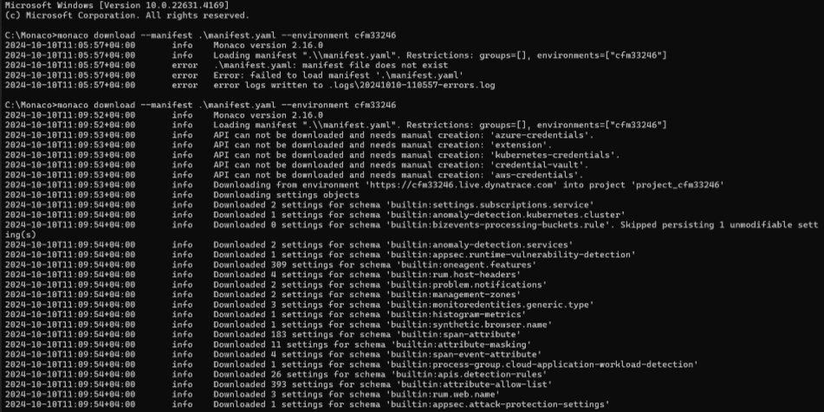

After executing the command, you should see the downloaded file in the folder.

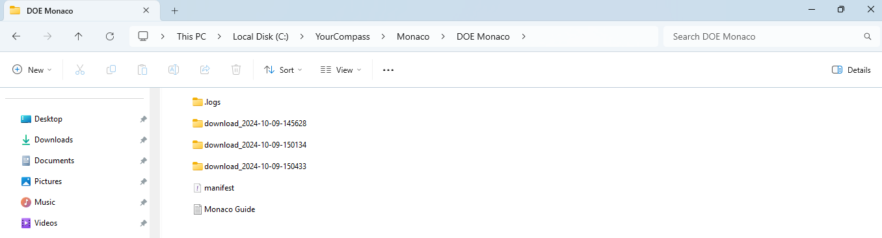

UPLOAD CONFIGURATIONS:

To Upload the downloaded configurations. We will navigate to folder where are configurations are saved and open the downloaded file.
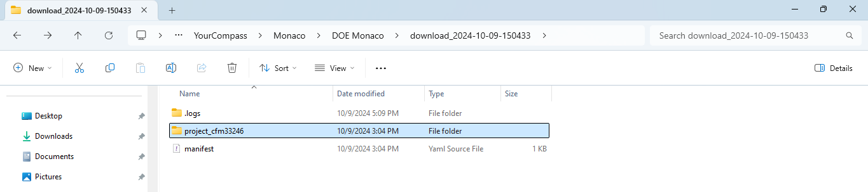

- Create a copy of manifest.yaml file as a backup, name it anything like manifest-copy.yaml.
- Access the environment where you want to migrate the configurations and generate a similar access token, just like the one created when downloading the configurations.
- Add the token to system environment variable similarly like we did before.
- Now edit the manifest.yaml file like below.
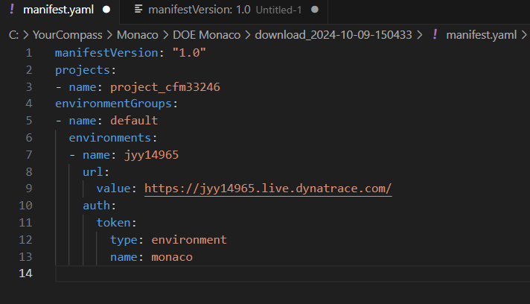
The changes will be Environment name : environmentId/tenantId , Url value: url of the new environment and token name: new environment token from new environment (if it is not saved with the same name).

Once the changes are complete, open the command prompt in the same directory or navigate to the path where the manifest.yaml file is saved, and then run the following command.
- monaco deploy --dry-run manifest.yaml - This Command will simulate the deployment without actually applying any changes to the Dynatrace environment. It is useful for testing and validating the configurations before executing the real deployment.
- monaco deploy manifest.yaml - This is the core command for deploying Dynatrace configurations defined as code to one or more environments.

